SPH4U0 Newton’s Laws Review and Activity Date:_______________

Sir Isaac Newton is famous for his three laws of motion as well as for his studies of gravity and optics.

Use the terms below to complete the summary of Newton’s Three Laws:
First Law Second Law Third Law
rest velocity mass
action reaction equal
unbalanced accelerate constant
zero inertia opposite

Newton’s ______________________ states that if the net force on an object is zero then the object will continue in a state of ___________ or ______________ ______________. The property of an body to maintain the same state of motion is referred to as ______________. This depends only on an object’s ________.

Newton’s __________________ applies when the forces on an object are _________________. If the net force on an object is not _____________, then the object will _____________ in the direction of the net force.

Newton’s ____________________ is often referred to as the ______________- _____________
Law. It states that if object A exerts a force on object B, then object B exerts an _____________
and ___________________ force on object A.

Investigation of Newton’s First Law and Second Laws: The Coin and the Card Trick
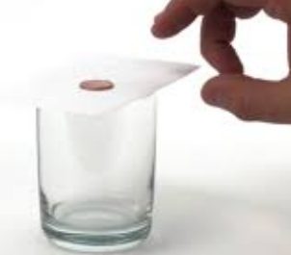
Place a coin on top of a cue card and place the card over the mouth
of a beaker. Flick the card with your fingers as shown to move it rapidly
sideways.
Describe what happens:

Use Newton’s First Law to explain the coin’s behavior:

Now try to move the card SLOWLY sideways by holding it between two fingers and pulling gently.
What happens to the coin in this case?

Explain the behavior of the coin by referring to Newton’s Second Law!

Investigation of Newton’s Second and Third Laws: Balloon Rocket
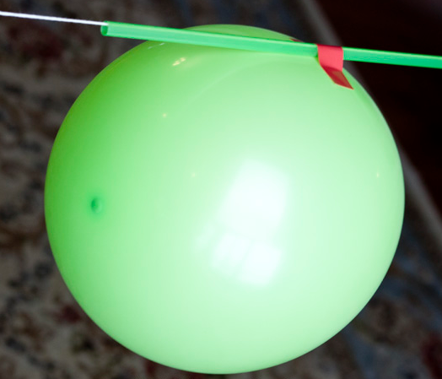
Materials: string, balloon, tape, straw, chairs or retort stands, masses (extra pennies or tongue depressors), measuring tape
Instructions: Cut a length of string several metres long. Thread
the string through the straw. Attach the string to the backs of
two chairs, moving the chairs so the string is taut.

Blow up your balloon to a moderate size and measure the balloon
circumference using the measuring tape. Pinch the balloon
mouth to keep the air in but don’t tie the mouth.

Attach the balloon to the straw on the string as shown and move it over to one end of the string. Release the balloon mouth and record your observations. Repeat the experiment for different amounts of balloon inflation and added mass.
Observations of Balloon Motion:
Balloon Inflation | Balloon Diameter (cm) | Qualitative Observation of motion  (e.g. fast or slow,  Hit the end or stopped before the end) | Distance travelled
Small amount of air
Medium amount of air
Large amount of air
Medium amount of air and with mass added to balloon (items added:
_______________)

Discussion:
1.Newton’s Second Law is expressed mathematically as F_{net}= ma. How was the force being varied in this activity? Do you see a qualitative relationship between force and acceleration? Explain your answer.

2. How was the mass varied in this activity? Do you see a qualitative relationship between
acceleration and mass? Explain your answer.

3. Newton’s Third Law is known as the Action-Reaction law. If the two “objects” interacting in this case were the balloon and the contained air, draw an action-reaction diagram illustrating how the two interacted.

